
“An experience for life”



Leaders manual

……………………………………………………


………………………
WELCOME TO WEEKAWAY!

We hope your stay here will be an enjoyable one.
Be sure to involve yourself in all the activities and have a great time.

Set on 72 peaceful acres in the quiet Benloch valley, Weekaway offers primary students up to Year 7 the opportunity to have “an experience for life”.

The General Conditions of Hire and Emergency Response Plan are included in the Teacher’s Kit sent to the Group Leader. This Leader’s Manual is designed for all Leaders attending camp.

On Arrival: The school will be greeted by our friendly staff who will assist with unloading bus/es and escorting students to the Main Accommodation Building where bags will be placed outside. Students will be shown inside the Central Lounge of the Main Accommodation Building where they will be taken through the Camp Rules and other information regarding their camp. Please make yourself comfortable on the chairs in the Central Lounge whilst this talk is underway.

Following the talk students will be given time, under school staff supervision, to place their bags in their room before our staff take you on an orientation walk around the campsite. Our staff will then discuss with all school leaders the various activities to be undertaken during your stay whilst the students have lunch under the supervision of our activity staff.

Supervision of students: At ALL TIMES it is the responsibility of SCHOOL STAFF (and parents if present) to supervise and attend to students whilst at Weekaway. Some of our activities are run by Weekaway Activity Co-ordinators, however, school staff may be required to assist with running the activity and dealing with any unacceptable behavior.

General Facilities: As there is little to no mobile phone service at Weekaway. A Phone is available in the Dining Room for incoming calls only. The Phone number for this Phone is (03) 5429 1708. It is best to advise incoming callers to phone during meal times, as the Dining Room is often unattended at other times. Other calls can be made on the phone in the Kitchen Office.
There are two large clothes lines behind the Main Accommodation Building. A Drying Room is available overnight if clothing is not likely to dry on the lines. There are no public laundry facilities. If laundry is required please speak with one of the Managers.
Duty Groups: Duty Groups of 8 – 14 students are required 15 minutes prior to each meal. Their responsibilities include setting the tables before meals, clearing away plates, cutlery etc. during and after each meal, help in putting away clean dishes, wiping down the tables and preparing for vacuuming of the dining room floor. Weekaway Staff will wash all dirty dishes and cutlery prior to putting them through the sanitizer.

Meals: Weekaway offers three home cooked meals a day. Times are as follows:
Breakfast 8.00am
Lunch 12.30
Dinner 5:30 or 6.00pm
Biscuits and fruit are available for morning and afternoon teas. Fresh fruit is available at all times. Supper is also provided and left to school staff to serve when evening activities are complete.

Weekaway Staff serve all meals and also supervise students with the table setting and clearing. School staff are required for supervision of students at all times.

Safety: All accommodation is fitted with hard wired smoke detectors which are checked prior to each camp. Fire Extinguishers are located around the buildings and are checked by the C.F.A every six months and by camp management weekly, however any concerns or damage should be reported to staff immediately. Emergency numbers are listed in this manual.

Damage: Any damage should be reported to camp staff as soon as possible. Any damage to windows, doors, bunks, fire extinguishers etc. will be charged to the School.

On Departure: It is the groups’ responsibility to leave the Camp in the same condition it was on arrival. Students are expected to remove their pillow case from the pillow they slept on during camp as well as remove rubbish from their rooms and surroundings. An ‘Emu Parade’ will be conducted prior to the school’s departure to pick up any rubbish around the campsite.

Attending Staff: Staff and helpers accompanying the students are responsible for supervision of the students at all times including meal times and at night. 1 staff member per 10 students attends free of charge. Carers may also attend free of charge with prior notice to the campsite. Extra staff and helpers are welcome to attend at a charge. Staff and helpers are expected to sleep in the Main Accommodation area with the students.

It is attending staff’s responsibility to ensure that:
Campers under 18 years of age have appropriate parent/guardian consent to attend the camp
The campsite’s Accident/Injury register is filled out for all such incidents
All day visiting members of the group are advised of the campsite’s safety briefing and ‘General Conditions of Hire’ and Weekaway staff are notified of their attendance.
Campers adhere to Sun safety strategies
Weekaway activity staff are advised of camper medical conditions or behavior that may arise and may place the campers or others at risk.

Activities: An exciting and stimulating activity program will be designed in consultation with the Group Leader prior to arrival at camp. Programs and Rotations will be displayed in the Accommodation areas and Dining Room.

Specialised activities are conducted by our Activity Co-ordinators with assistance from school staff. Other activities are conducted by school staff after instruction at the start of camp. All equipment is provided. A detailed description of each activity can be found in the Teacher’s Kit.

Day Trips: A Picnic at Hanging Rock may be incorporated into the program if time permits. School staff take full responsibility of the care and supervision of students at Hanging Rock. A packed lunch will be provided.

Free Time Activities: There are many activities to do outside during free time. These include, but are not limited to:
- Basketball (inside the Recreation Hall)
- Volleyball
- Cricket
- Ball games (soccer/football etc.)
There is a large open grassed area at the front of the Accommodation and Dining Buildings for ball games. Schools are required to bring their own sports equipment for free time use.

Free time is a great opportunity for students to mix and chat with other students in different activity groups, as well as get to know teachers on camp.

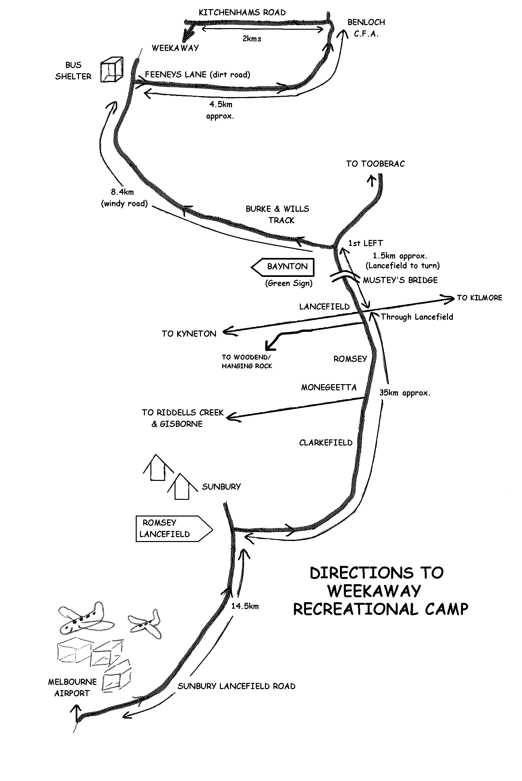
Mud Map:

Lancefield to Weekaway
CAMP RULES

These rules are also listed in the Student Booklet.

- Staff are responsible for maintaining the Coonara Fire
- Smoking only permitted on the grassed area behind the kitchen
- Breakages and losses are to be reported as they occur. All damage will be charged for
- No food or drink is to be consumed in the sleeping quarters
- No chewing gum in the camp
- Bedding is NOT to be removed from rooms
- Fences are NOT to be crossed unless under staff supervision
- Please think of others and limit your shower time to 3 minutes
- Set rotating activities (eg. Canoeing, Sailing, Ropes Course, Initiatives etc.) are NOT “free time” activities and must only be done under staff supervision
- Students are NOT to go near the dams or up on the hills unless under Teacher supervision
- Fire hydrants, hoses, extinguishers and smoke detectors are for YOUR protection in an emergency. They must NOT be interfered with or used for any other purpose
- The siren means you must report immediately to the Dining Room. If we have a power failure, then we will use air horns to call everyone in
- Be on time for your duty group, meals and activities
- No shoes or gumboots are to be worn inside the Accommodation Areas
- Once you leave the Accommodation Building you MUST have something on your feet (and NOT just socks!!)
- Place rubbish in the bins provided. Bring all rubbish back from the bush. Help protect our native wildlife by not giving them our food, and by not leaving rubbish lying around. Remember “Do The Right Thing”
- Please conserve the natural environment – it is there to be enjoyed by all
MOST IMPORTANT – HAVE A GREAT TIME!

WHAT TO BRING

- Sleeping Bag or Doona (an extra blanket can be handy when its cold)
(Fitted sheet, pillow & pillow slip provided)
- Pyjamas or tracksuit
- Slippers, or shoes for wearing inside
- Water proof jacket
- Underwear including socks (1 pair for each day + 2 spare; anklet socks NOT recommended)
- Shorts, jeans and tracksuit (if you are doing water sports in winter, please bring an extra tracksuit that you can get wet)
- Jumpers
- Shirts; T-shirts
- Shoes, boots, runners that can get wet, in winter gumboots are handy (at least 2 pairs of shoes, old ones are best)
- Toiletries (toothbrush, tooth paste, hair brush, soap, insect repellant etc.)
- Bath towel & face washer
- Bathers & swim towel
- Torch & spare batteries
- Small packet of tissues
- Garbage bag for dirty clothes
- Hat & sunscreen
- Drink bottle
- Medication – to be handed to school staff
- Day pack
- Lunch for the first day
Cameras are permitted but no responsibility will be taken for damage or loss

VERY IMPORTANT :
Weekaway encourages campers to be Sun Safe at all times, therefore remember to bring sunscreen, a hat and a water bottle.

It is also important that campers give their personal medications to teachers prior to departing for camp (eg. Asthma puffers)

WHAT not TO BRING

- Good Clothes
- Valuable Items
- Computerised Games

- Jewellery
- Chewing Gum!
- Snack food containing egg or nuts

SITE PLAN
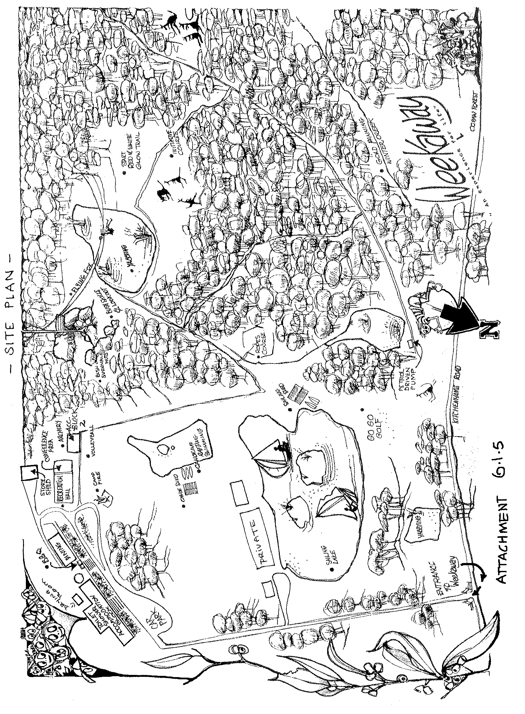

Main Accommodation Building - Girls

Room 1 |  |  | Room 2
(Teacher’s) |  |  | 1
1 |  |  | 2
2 |  |  | 3
 |  |  | 4
 |  |  | 5
 |  |  | 6
Room 3 |  |  | Room 4
1 |  |  | 1
2 |  |  | 2
3 |  |  | 3
4 |  |  | 4
5 |  |  | 5
6 |  |  | 6
Room 5 |  |  | Room 6
1 |  |  | 1
2 |  |  | 2
3 |  |  | 3
4 |  |  | 4
5 |  |  | 5
6 |  |  | 6
Room 7 |  |  | Room 8
1 |  |  | 1
2 |  |  | 2
3 |  |  | 3
4 |  |  | 4
5 |  |  | 5
6 |  |  | 6
Room 9 |  |  | Room 10
1 |  |  | (Teacher’s)
2 |  |  | 1
3 |  |  | 2
4
5
6

Main Accommodation Building - Boys

Room 11 |  |  | Room 12
(Teacher’s) |  |  | 1
1 |  |  | 2
2 |  |  | 3
 |  |  | 4
 |  |  | 5
 |  |  | 6
Room 13 |  |  | Room 14
1 |  |  | 1
2 |  |  | 2
3 |  |  | 3
4 |  |  | 4
5 |  |  | 5
6 |  |  | 6
Room 15 |  |  | Room 16
1 |  |  | 1
2 |  |  | 2
3 |  |  | 3
4 |  |  | 4
5 |  |  | 5
6 |  |  | 6
Room 17 |  |  | Room 18
1 |  |  | 1
2 |  |  | 2
3 |  |  | 3
4 |  |  | 4
5 |  |  | 5
6 |  |  | 6
Room 19 |  |  | Room 20
1 |  |  | (Teacher’s)
2 |  |  | 1
3 |  |  | 2
4
5
6

Cottage

Room 21 |  |  | Room 22
(Teacher’s) |  |  | 1
1 |  |  | 2
2 |  |  | 3
3 |  |  | 4
 |  |  | 5
 |  |  | 6
Room 23 |  |  | Room 24
1 |  |  | 1
2 |  |  | 2
3 |  |  | 3
4 |  |  | 4
5 |  |  | 5
6 |  |  | 6

ACTIVITY GROUPS

Group A |  |  | Group B |  |  | Group C
1 |  |  | 1 |  |  | 1
2 |  |  | 2 |  |  | 2
3 |  |  | 3 |  |  | 3
4 |  |  | 4 |  |  | 4
5 |  |  | 5 |  |  | 5
6 |  |  | 6 |  |  | 6
7 |  |  | 7 |  |  | 7
8 |  |  | 8 |  |  | 8
9 |  |  | 9 |  |  | 9
10 |  |  | 10 |  |  | 10
11 |  |  | 11 |  |  | 11
12 |  |  | 12 |  |  | 12
13 |  |  | 13 |  |  | 13
14 |  |  | 14 |  |  | 14

Group D |  |  | Group E |  |  | Group F
1 |  |  | 1 |  |  | 1
2 |  |  | 2 |  |  | 2
3 |  |  | 3 |  |  | 3
4 |  |  | 4 |  |  | 4
5 |  |  | 5 |  |  | 5
6 |  |  | 6 |  |  | 6
7 |  |  | 7 |  |  | 7
8 |  |  | 8 |  |  | 8
9 |  |  | 9 |  |  | 9
10 |  |  | 10 |  |  | 10
11 |  |  | 11 |  |  | 11
12 |  |  | 12 |  |  | 12
13 |  |  | 13 |  |  | 13
14 |  |  | 14 |  |  | 14

ACTIVITY GROUPS (cont’d)

Group G |  |  | Group H |  |  | Group I
1 |  |  | 1 |  |  | 1
2 |  |  | 2 |  |  | 2
3 |  |  | 3 |  |  | 3
4 |  |  | 4 |  |  | 4
5 |  |  | 5 |  |  | 5
6 |  |  | 6 |  |  | 6
7 |  |  | 7 |  |  | 7
8 |  |  | 8 |  |  | 8
9 |  |  | 9 |  |  | 9
10 |  |  | 10 |  |  | 10
11 |  |  | 11 |  |  | 11
12 |  |  | 12 |  |  | 12
13 |  |  | 13 |  |  | 13
14 |  |  | 14 |  |  | 14

DUTY GROUPS

Duty Groups of 8 – 15 students are required to assist the Weekaway staff set up prior to meals and clean up afterwards. Please allocate one duty group for each meal – breakfast, lunch, dinner, morning and afternoon teas. A member of school staff is required to be present with the duty group during setting up and after meals to supervise, assist and direct students.

Duty groups should report to the Dining Room 15 minutes before each meal to begin setting up. Duties before meals include:

- Setting the tables with utensils, cups and condiments

After meals, the duty group helps with the following duties:

- Collecting dishes and stacking them for Weekaway staff to wash and put through the sanitizer
- Putting dishes away after they’ve been through the sanitizer
- Wiping down the tables
- Stacking chairs for Weekaway staff to vacuum
- Sweeping the floor and tidying the dining room

PROGRAM & ROTATIONS

(INSERT YOUR PROGRAM & ROTATIONS INTO THE BOOKLET HERE)

WEEKAWAY IN AN EMERGENCY
1. Verify | Verify the report.  - Confirm with school staff, other campers, Emergency Services or other reliable people the accuracy of the information about the emergency.
2. Notify | Notify Weekaway staff and Emergency Services  By the quickest possible means, immediately notify:  - Weekaway Management (dial 52 on the kitchen phone) who will alert the Emergency Services as necessary.
3. Assess | Assess the danger posed by the emergency  - Use all your senses to build a picture which tells you what is happening and use that information to help decide on a course of action.  - Use verbal information.  - Observe what is happening to decide:  - has the danger passed?  - is the danger increasing or decreasing?  - is the danger coming closer or moving further away?  - is the weather or terrain affecting its progress?  - decide how much time exists to take alternative actions.
4. Act  Assembly Areas: Dining Room or Main Grassed Area  Emergency Bell @ Kitchen | Take action based on the assessment of danger.  - ensure that injured campers are not exposed to further injury or danger.  - contain the emergency if safe to do so.  - move people away from the danger area by the safest means, if necessary, move campers indoors, to one end of the building, to the furthermost part of the campsite or to a site well away from the campsite if time permits.  - refer to any specific procedures developed for the emergency.

Your location: Weekaway, 186 Kitchenhams Road, BENLOCH Vic. 3435

Melways map 609 H8 . Vic Country Roads Map 60 C5

Office Phone: (03) 5429 1503 Fax: (03) 5429 2196
Emergency Phone Numbers
Fire - Police - Ambulance – Dial 000
Hospital (Kyneton) 5422 9900 |  | Doctor (Romsey) 5429 5254 | Dentist (Kilmore) 5782 1933
Dept. of Ed 24 hour 9589 6266 |  | SES 132 500 | Poisons Info 131 126
Plumber 5422 1381 |  | Electrician 0419 548 471 | Glazier (Romsey) 5429 5204
Gas supplier (Elgas) 131 161 |  | Power (Powercor) 132 412………….. | (NMI 6203 4734 908)

WEEKAWAY
MAP: WEEKAWAY TO KYNETON HOSPITAL:

VIC ROADS REF J11

