
“An experience for life”

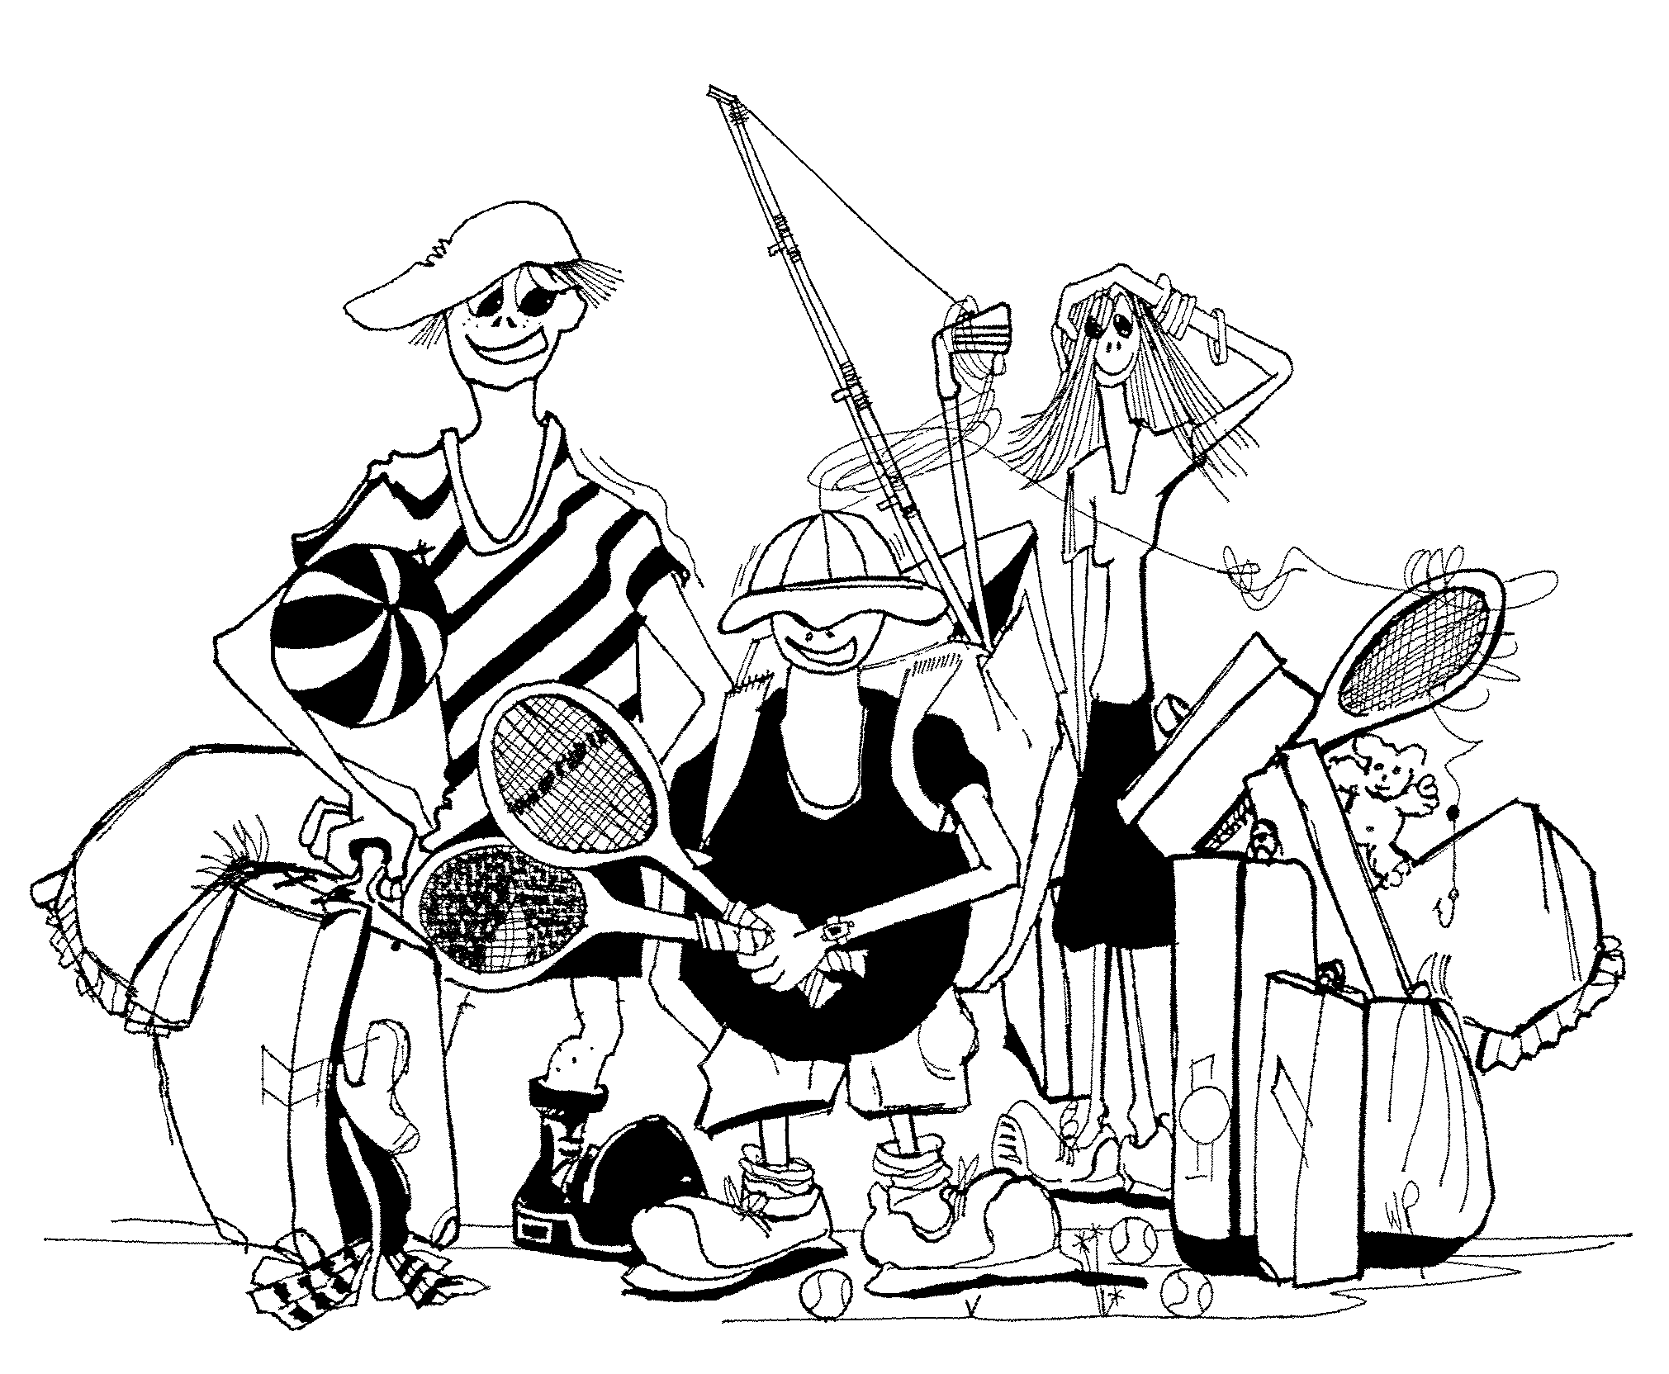

Student Handbook

Name: ……………………………………………


…………………………………………
WELCOME TO WEEKAWAY!

We hope your stay here will be an enjoyable one.

CAMP RULES

- Staff are responsible for tending the Coonara Fire
- If you break something – tell someone
- No food or drink in the Accommodation Building
- No chewing gum in the camp
- Leave bedding in the bedrooms
- Stay within the camp boundaries unless under staff supervision
- Please think of others and limit your shower time to 3 minutes
- Set rotating activities (eg. Canoeing, Sailing, Ropes Course, Initiatives etc.) are NOT “free time” activities and must only be done under staff supervision
- DON’T go near the dams or up on the hills unless with a Teacher
- Fire hydrants, hoses, extinguishers and smoke detectors are for YOUR protection in an emergency. They must NOT be interfered with or used for any other purpose
- The siren means go to the Dining Room. If we have a power failure, then we will use air horns to call everyone in
- Be on time for your duty group, meals and activities
- No shoes or gumboots are to be worn inside the Accommodation Areas
- Once you leave the Accommodation Building you MUST have something on your feet (and NOT just socks!!)
- Remember all rubbish to be placed in bins - “Do The Right Thing”
- Please conserve the natural environment – it is there to be enjoyed by all
MOST IMPORTANT – HAVE A GREAT TIME!
WHAT TO BRING

- Sleeping Bag or Doona (an extra blanket can be handy when its cold)
(Fitted sheet, pillow & pillow slip provided)
- Pyjamas or tracksuit
- Slippers, or shoes for wearing inside
- Water proof jacket
- Underwear including socks (1 pair for each day + 2 spare; anklet socks NOT recommended)
- Shorts, jeans and tracksuit (if you are doing water sports in winter, please bring an extra tracksuit that you can get wet)
- Jumpers
- Shirts; T-shirts
- Shoes, boots, runners that can get wet, in winter gumboots are handy (at least 2 pairs of shoes, old ones are best)
- Toiletries (toothbrush, tooth paste, hair brush, soap, insect repellant etc.)
- Bath towel & face washer
- Bathers & swim towel
- Torch & spare batteries
- Small packet of tissues
- Garbage bag for dirty clothes
- Hat & sunscreen
- Drink bottle
- Medication – to be handed to school staff
- Day pack
- Lunch for the first day
Cameras are permitted but no responsibility will be taken for damage or loss

VERY IMPORTANT :
Weekaway encourages campers to be Sun Safe at all times, therefore remember to bring sunscreen, a hat and a water bottle.

It is also important that campers give their personal medications to teachers prior to departing for camp (eg. Asthma puffers)

WHAT not TO BRING

- Good Clothes
- Valuable Items
- Computerised Games

- Jewellery
- Chewing Gum!
- Snack food containing egg or nuts

ABOUT WEEKAWAY

Set on 72 peaceful acres in the quiet Benloch valley, Weekaway offers primary students up to Year 7 the opportunity to have “an experience for life”.

On Arrival: You will be greeted by our friendly staff who will assist with unloading bus/es and escorting you to the Main Accommodation Building where bags will be placed outside. You will then be shown inside the Central Lounge of the Main Accommodation Building where you will be told about the Camp Rules and other camp information. Please be seated on the floor facing the Coonara Fire.

Following the talk school staff will ask you to place your bags in your room before our staff take you on an orientation walk around the campsite.

Duty Groups: Duty Groups of 8 – 14 students are required 15 minutes prior to each meal. Your responsibilities include setting the tables before meals, clearing away plates, cutlery etc. during and after each meal, help in putting away clean dishes, wiping down the tables and preparing for vacuuming of the dining room floor. Weekaway Staff will wash all dirty dishes and cutlery prior to putting them through the sanitizer.

Meals: Weekaway offers three home cooked meals a day. Times are as follows:
Breakfast 8.00am
Lunch 12.30
Dinner 5:30 or 6.00pm
Biscuits and fruit are available for morning and afternoon teas. Fresh fruit is available at all times. Supper is also provided and left to school staff to serve when evening activities are complete.

On Departure: It is the groups’ responsibility to leave the Camp in the same condition it was on arrival. Students are expected to remove their pillow case from the pillow they slept on during camp as well as remove rubbish from their rooms and surroundings. An ‘Emu Parade’ will be conducted prior to the school’s departure to pick up any rubbish around the campsite.

Free Time Activities: There are lots of activities to do outside during free time. These include, but are not limited to:
- Basketball (inside the Recreation Hall)
- Volleyball
- Cricket
- Ball games (soccer/football etc.)
There is a large open grassed area at the front of the Accommodation and Dining Buildings for ball games.
SITE PLAN
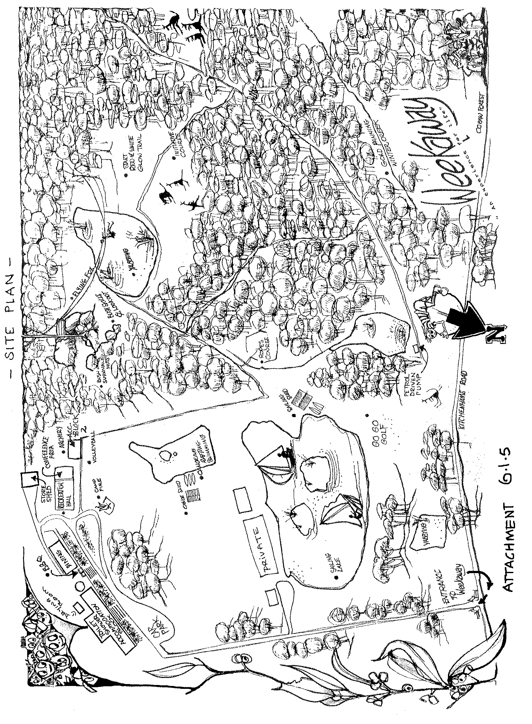

Bunk Room

Who is in my Bunk Room?

Cabin Number: ______

1
2
3
4
5
6

Activity Group

Who is in my Activity Group?

Activity Group Name: _____________________

DUTY GROUPS

Duty Groups of 8 – 15 students are required to assist the Weekaway staff set up prior to meals and clean up afterwards.

Duty groups should report to the Dining Room 15 minutes before each meal to begin setting up. Duties before meals include:

- Setting the tables with utensils, cups and condiments

After meals, the duty group helps with the following duties:

- Collecting dishes and stacking them for Weekaway staff to wash and put through the sanitizer
- Putting dishes away after they’ve been through the sanitizer
- Wiping down the tables
- Stacking chairs for Weekaway staff to vacuum
- Sweeping the floor and tidying the dining room

Who is in my Duty Group?

PROGRAM & ROTATIONS

(INSERT YOUR PROGRAM & ROTATIONS INTO THE BOOKLET HERE)

My Camp Diary…..

DAY ONE

Highlight of the day……

My Camp Diary…..

DAY TWO

Highlight of the day……

My Camp Diary…..

DAY THREE

Highlight of the day……

My Camp Diary…..

DAY FOUR

Highlight of the day……

My Camp Diary…..

DAY FIVE

Highlight of the day……

GAMES FOR THE BUS TRIP

Eye Spy…….

On the bus ride to Weekaway, see how many things you can spot outside the bus that begin with each letter of the alphabet.

A | B
C | D
E | F
G | H
I | J
K | L
M | N
O | P
Q | R
S | T
U | V
W | X
Y | Z

WEEKAWAY WORD FIND

S | C | H | O | O | L | E | T | T | O | L | R | A | H | C
H | S | C | A | N | T | K | A | N | G | A | R | O | O | S
U | S | E | N | K | N | C | A | S | D | G | L | B | L | A
T | P | U | E | U | R | U | P | N | T | C | O | Z | B | O
Y | S | W | B | A | S | K | E | T | B | A | L | L | P | R
D | O | S | E | P | O | R | R | G | A | M | E | S | F | A
I | F | U | N | E | F | U | H | S | T | P | U | T | T | E
S | H | B | L | T | K | M | I | I | A | F | R | U | O | C
C | A | N | O | E | C | A | M | P | N | I | D | H | R | H
O | N | D | C | X | S | T | W | E | F | R | O | R | I | I
T | G | V | H | T | O | D | I | A | N | E | Y | D | E | D
Z | I | D | X | O | F | G | N | I | Y | L | F | A | N | N
I | N | I | T | I | A | T | I | V | E | S | O | R | T | A
A | G | L | O | W | T | R | A | I | L | S | O | R | E | D
T | R | E | K | N | O | C | K | R | S | E | D | E | E | N
S | O | C | K | B | P | N | U | I | Z | M | S | N | R | I
J | C | P | H | Y | M | L | S | A | O | A | A | P | I | L
W | K | D | N | E | I | R | F | T | K | J | N | D | N | O
W | A | T | E | R | R | O | G | A | I | N | I | N | G | C
S | E | I | B | B | A | Y | S | G | Y | E | C | A | T | S

ARCHERY
ARTHUR
BASKETBALL
BENLOCH
BUNK
BUSH
CAMP
CAMPFIRE
CANOE
CHARLOTTE
DAMS
DARREN
DISCO
ECHIDNA
FLYING FOX
FOOD
FUN
GI JANE
GAMES
GLOW TRAILS
GOLF
HANGING ROCK
HOT EATS
HUTS
INITIATIVES
KANGAROOS
KNOCK
ORIENTEERING
ROGAINING
ROPES
SCHOOL
SNOW
VOLLEYBALL
WATER
WEEKAWAY
YABBIES

WEEKAWAY WORD PUZZLE

How many words can you make using the letters from…

Weekaway Recreation Camp

~~ NOUGHTS & CROSSES ~~

~~ SQUARES GAME ~~

→ | → | → | → | → | → | → | → | → | → | → | → | → | → | → | → | → | → | → | →
→ | → | → | → | → | → | → | → | → | → | → | → | → | → | → | → | → | → | → | →
→ | → | → | → | → | → | → | → | → | → | → | → | → | → | → | → | → | → | → | →
→ | → | → | → | → | → | → | → | → | → | → | → | → | → | → | → | → | → | → | →
→ | → | → | → | → | → | → | → | → | → | → | → | → | → | → | → | → | → | → | →
→ | → | → | → | → | → | → | → | → | → | → | → | → | → | → | → | → | → | → | →
→ | → | → | → | → | → | → | → | → | → | → | → | → | → | → | → | → | → | → | →
→ | → | → | → | → | → | → | → | → | → | → | → | → | → | → | → | → | → | → | →
→ | → | → | → | → | → | → | → | → | → | → | → | → | → | → | → | → | → | → | →
→ | → | → | → | → | → | → | → | → | → | → | → | → | → | → | → | → | → | → | →
→ | → | → | → | → | → | → | → | → | → | → | → | → | → | → | → | → | → | → | →
→ | → | → | → | → | → | → | → | → | → | → | → | → | → | → | → | → | → | → | →
→ | → | → | → | → | → | → | → | → | → | → | → | → | → | → | → | → | → | → | →
→ | → | → | → | → | → | → | → | → | → | → | → | → | → | → | → | → | → | → | →

AUTOGRAPHS

